Hostel Management System

Abdul Basit Bhat 102003121

Anmolpreet kaur 102183003

Shashmita Maharana 102183024

aryaman kalia 102003099

aarushi 102053020

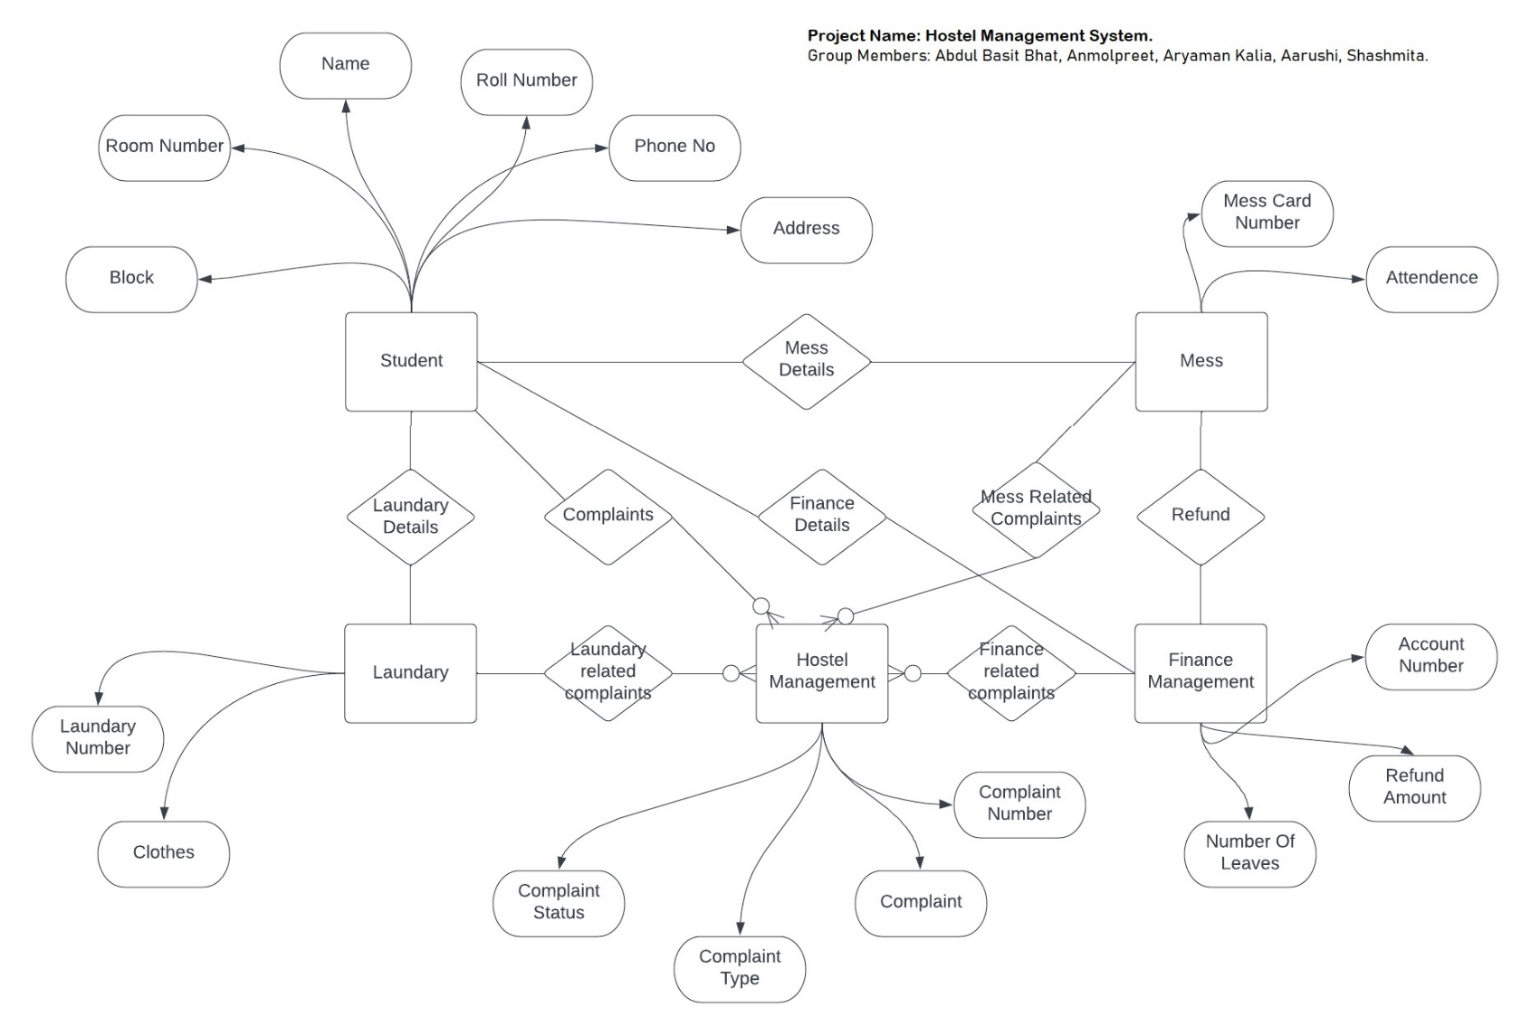

**Hostel Management System**

The idea of our project is to create a Hostel Management System. In our project we wil be using 5 Entitiey sets namely

1. Student

2. Mess

3. Laundary

4. Finance Management

5. Hostel Management

Student: In student table we will be adding columns like Name, Roll No, Phone No, Block,Room No and Address. This entity set will have relationships like 1 to 1 relationship with Laundary entity named as Laundary Details, 1 to 0 or many relationship with Hostel Management entity named as Complaints. 1 to 1 relationship with Finance Management entity and 1 to 1 relationship with Mess entity. Primary Key: Roll Number.

Mess: This entity set will store data realated to Mess card number and Attendence. The same data may be used by finance Management entity for derived attributes like No of leaves and Refund amount. The mess entity will also have a relationship with Hostel Management entity for mess complaints related data. Primary Key: Mess Card Number (Derived from roll Number attribute in Student entuty set) Foreign Key: Roll Number reference(Student)

Hostel Management: This entity set contains data related to compaints. It conatains attributes like Compalaint Number, Complaint Status, Complaint type and complaint. Primary Key: Complaint Number (generated by adding a unque 3 digit number to Roll Number foreign key used from student table) Foreign Key: Roll Number reference(Student)

Finance Management: This entity set contains data related to leaves and refund amount. It uses attributes from mess department to derive the respective data. Primary key: Account number(Generated by adding a prefix to Roll Number attribute from Student table).

Laundary: This entity set contains data related to Laundary card number and clotes given for washing. Primary Key: Laundary Number(generated by Phone Number attribute from Student table).Foreign Key: Roll Number reference(Student)

Note:

1. All of these entity sets are related to main student entity set and hence Student entity set can be used on the client side to get the respective data using appropriate querries.
2. For simplicity we have not indicated foreign key attributes for any entity set.